DATA PROTECTION USING HYBRID ENCRYPTION AND STEGANOGRAPHY
Design and Implementation
Department of Computer Science and Engineering, TKR College of Engineering & Technology
Batch A15 (CSE-A) · Academic year [ACADEMIC YEAR]
Table 1: Project team
S.No. | Student name | Roll number
1 | Allam Rakesh | 23K91A0509
2 | Bolleddu Shanker | 23K91A0543
3 | Agaram Sri Sarvagna | 23K91A0506
4 | B Akshay | 24K915A0504

Project guide: Rajalakshmi
Chapter and section numbers quoted in the text (for example Chapter 8 or Section 6.2) refer to the full project report, 17.Final Document. Figures and tables in this document are numbered from 1.

1. DESIGN
This chapter describes the architecture, the workflow, the data flow, the UML and data design, the modules, the interface design and the security design of CipherVeil. The diagrams were drawn from the code in backend/app/ and frontend/src/; the complete set, with longer explanations, is also in the Block Diagrams document.

1.1 Design Goals and Architecture
Five goals shaped the design. Two independent layers: the content must stay confidential even if the hiding is found, and the transfer must look like a picture. Standard primitives only: AES-256-GCM and RSA-OAEP-SHA256 from a maintained library [20], [21], [23], with no home-made cipher. Measurable behaviour: every message records PSNR, SSIM, capacity and timings. Honest limits: the interface must say what fails (a JPEG pass, a wrong key, an oversize file) and why. Small and testable: about 1,040 lines of backend code in 16 modules, each testable on its own.
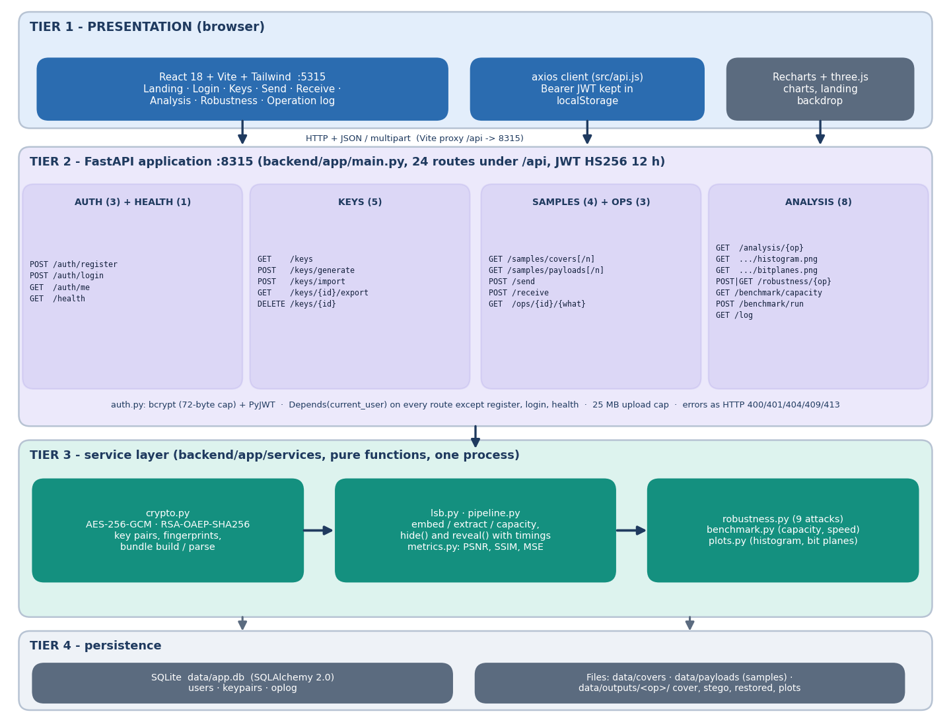
Figure 1: System architecture of CipherVeil: React console, FastAPI application with 24 endpoints, service layer, and the SQLite database and output files.
The React console on port 5315 calls the FastAPI application on 127.0.0.1:8315 through a Vite proxy that forwards /api. The application layer (backend/app/routes/) validates input, checks the bearer token and the ownership of every key and operation, and delegates to the service layer (backend/app/services/). The services hold the actual work: crypto (keys, AES-GCM, RSA-OAEP, bundle), lsb (capacity, embed, extract, PNG encoding), metrics (PSNR, SSIM), pipeline (the send and receive sequences, shared by the API, the benchmark and ml/eval.py), plots, robustness and benchmark. State is kept in a SQLite file (data/app.db, three tables) and in data/outputs/<op>/, where each send operation keeps its cover, its stego PNG and later its histogram and bit-plane images.

1.2 High-Level Workflow and Core Algorithm
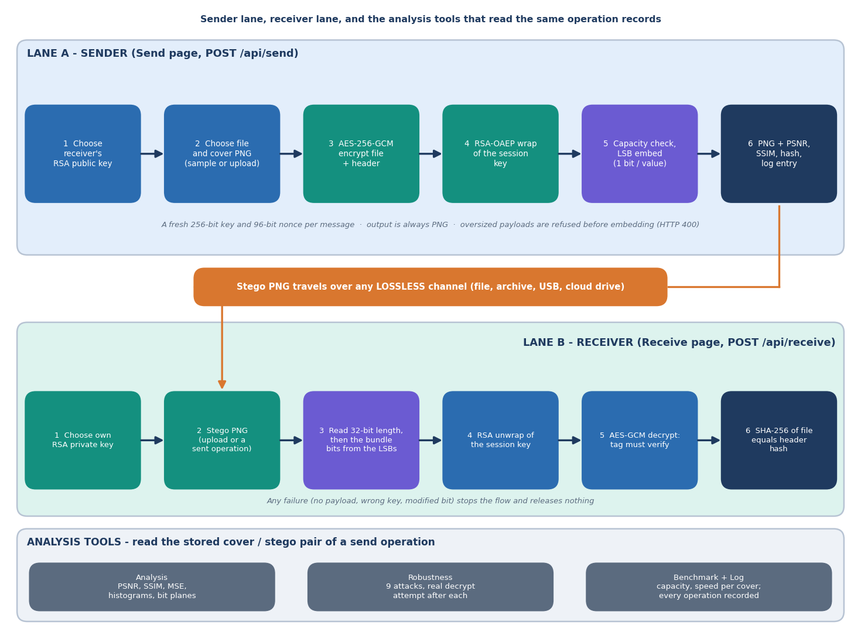
Figure 2: High-level workflow: the sender's path (encrypt, wrap, check capacity, embed, measure) and the receiver's path (extract, unwrap, verify).
Send. The sender selects the receiver's public key, a file and a cover. The service builds a header {name, size, sha256}, encrypts header_len | header | file with a fresh 256-bit AES key and a fresh 96-bit nonce (additional data: the magic CVL1), wraps the session key with the receiver's RSA public key, and assembles the bundle. If the bundle is longer than the cover capacity (width x height x 3 - 32) / 8 bytes the request is refused before anything is embedded. Otherwise the 32-bit length and the bundle are written, bit by bit, into the lowest bit of each red, green and blue value from the top-left pixel onwards, and the result is saved as a PNG. PSNR, SSIM and timings are then computed against the untouched cover.
Receive. The receiver extracts the length and the bundle from the lowest bits, rejects an image without a plausible header, checks the magic and the wrapped-key length, unwraps the session key with the private key, and decrypts. A wrong key, a flipped bit or a truncated bundle fails the GCM tag check and nothing is released. Finally the SHA-256 stored inside the encrypted header is compared with the hash of the restored file.
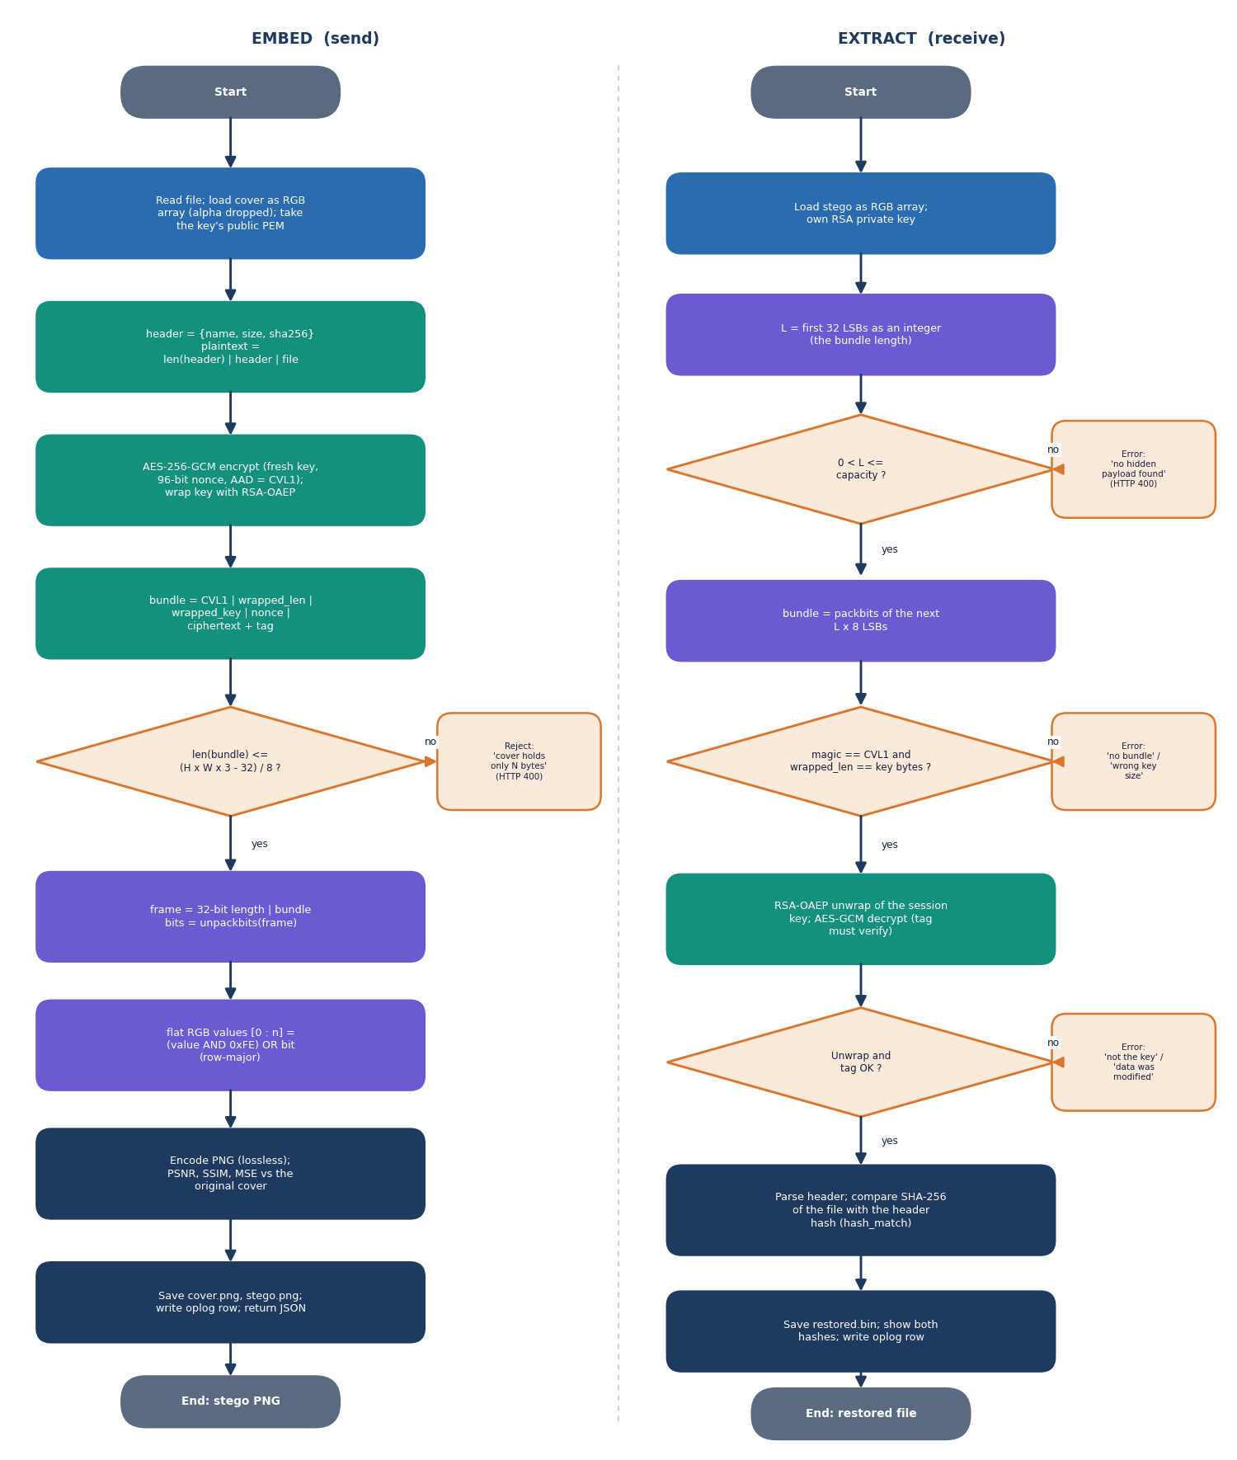
Figure 3: Flowchart of the core algorithm: encrypt and embed, extract and decrypt, with the refusal branches.
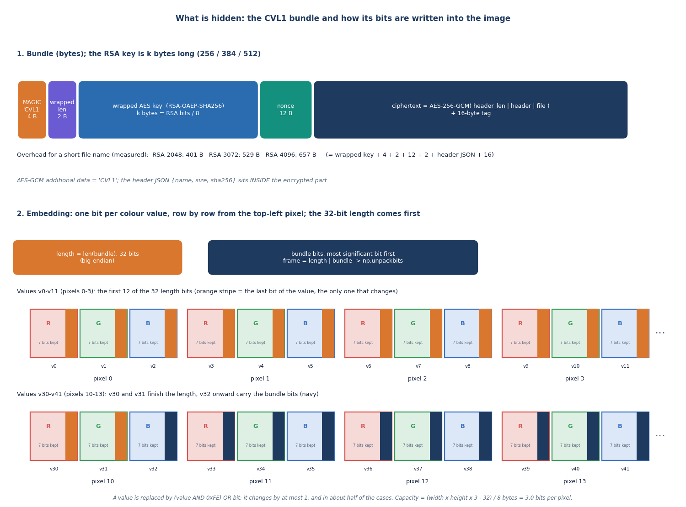
Figure 4: Layout of the CVL1 bundle that is hidden in the image, and its position in the LSB stream.
The bundle carries everything the receiver needs and nothing secret in the clear: the magic and the length of the wrapped key (6 bytes), the RSA-wrapped session key (256, 384 or 512 bytes for RSA-2048, 3072 or 4096), the nonce (12 bytes) and the ciphertext with its 16-byte tag. The fixed overhead is 401, 529 and 657 bytes for the three key sizes with a short file name.

1.3 Data Flow Diagrams

1.3.1 Level 0: context
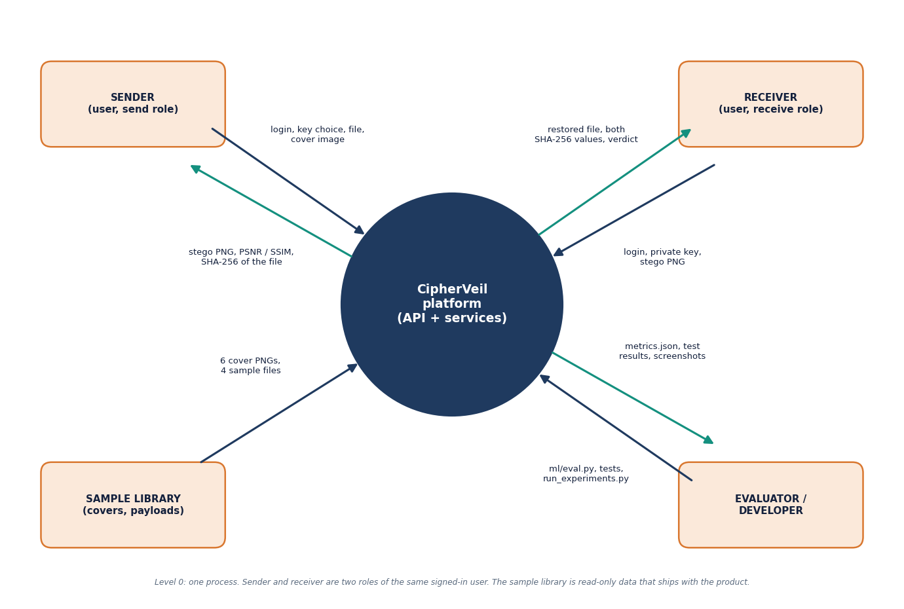
Figure 5: Data flow diagram, level 0: the user, the cover and payload files and the receiver exchange data with the CipherVeil platform.
At level 0 the platform is one process. The user sends credentials, key requests, a payload file, a cover image and a stego image to receive, and gets back keys, the stego PNG, the restored file, the two hashes, quality metrics and the log. The receiver is outside the platform in the sense that the public key goes to the sender and the stego PNG travels between them over a channel CipherVeil does not control. The evaluator runs the scripts and reads the result files.

1.3.2 Level 1: main processes
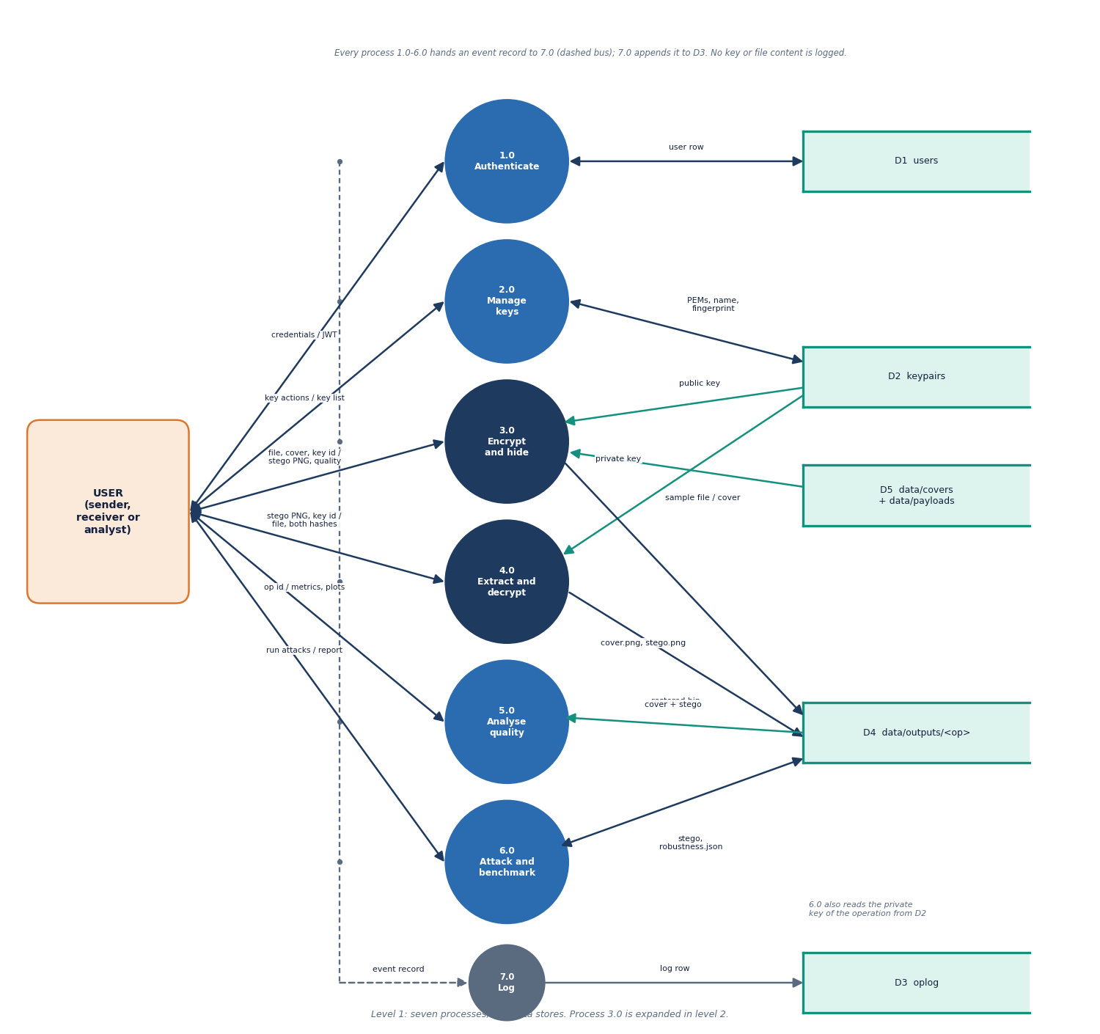
Figure 6: Data flow diagram, level 1: authenticate, manage keys, encrypt and embed, extract and decrypt, analyse, attack and benchmark, and log.
Level 1 splits the platform into processes for authentication (1.0), key management (2.0), encrypt and embed (3.0), extract and decrypt (4.0), analysis of imperceptibility (5.0), robustness and benchmark (6.0) and logging (7.0). The data stores are the user table, the key table (with the private half only for the owner's own keypairs), the operation log, and the output folder of cover, stego and restored files. The log never receives keys, passwords or file contents.

1.3.3 Level 2: encrypt and embed
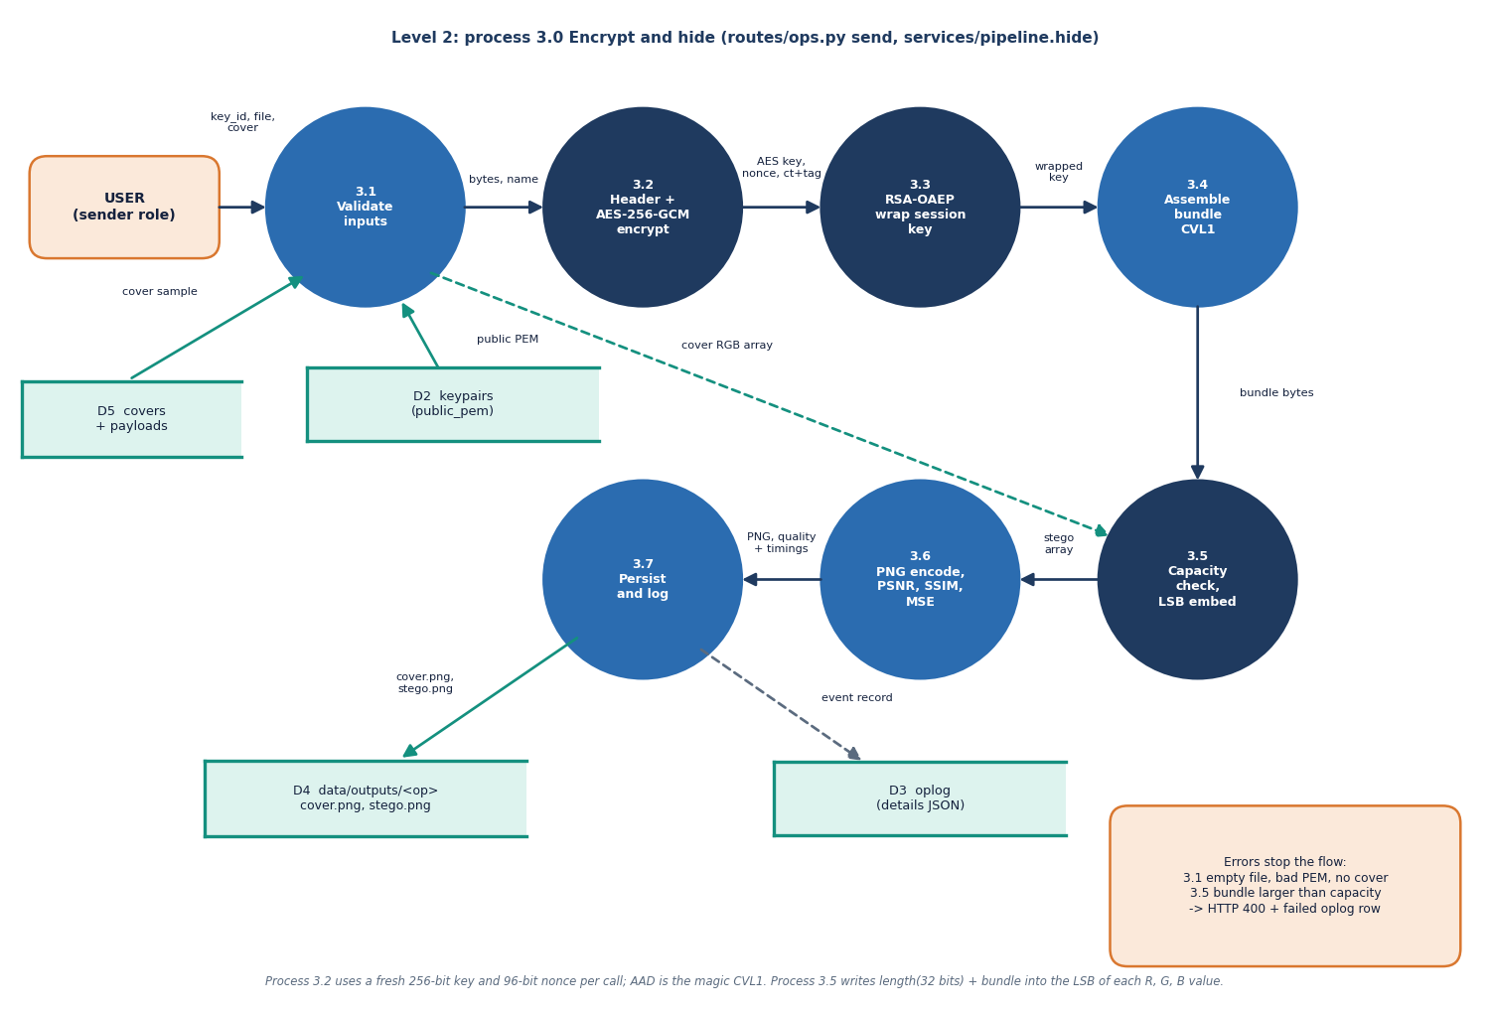
Figure 7: Data flow diagram, level 2: process 3.0 expanded into header, AES-GCM, key wrap, capacity check, embedding and metrics.
Process 3.0 expands into building the header and hashing the file, encrypting with AES-256-GCM, wrapping the session key with RSA-OAEP, assembling the bundle, checking capacity, embedding the bits, encoding the PNG and measuring PSNR and SSIM. The same sequence is used by the API, by the benchmark and by ml/eval.py, so the evaluation measures the code the user runs.

1.4 UML Design

1.4.1 Class diagram
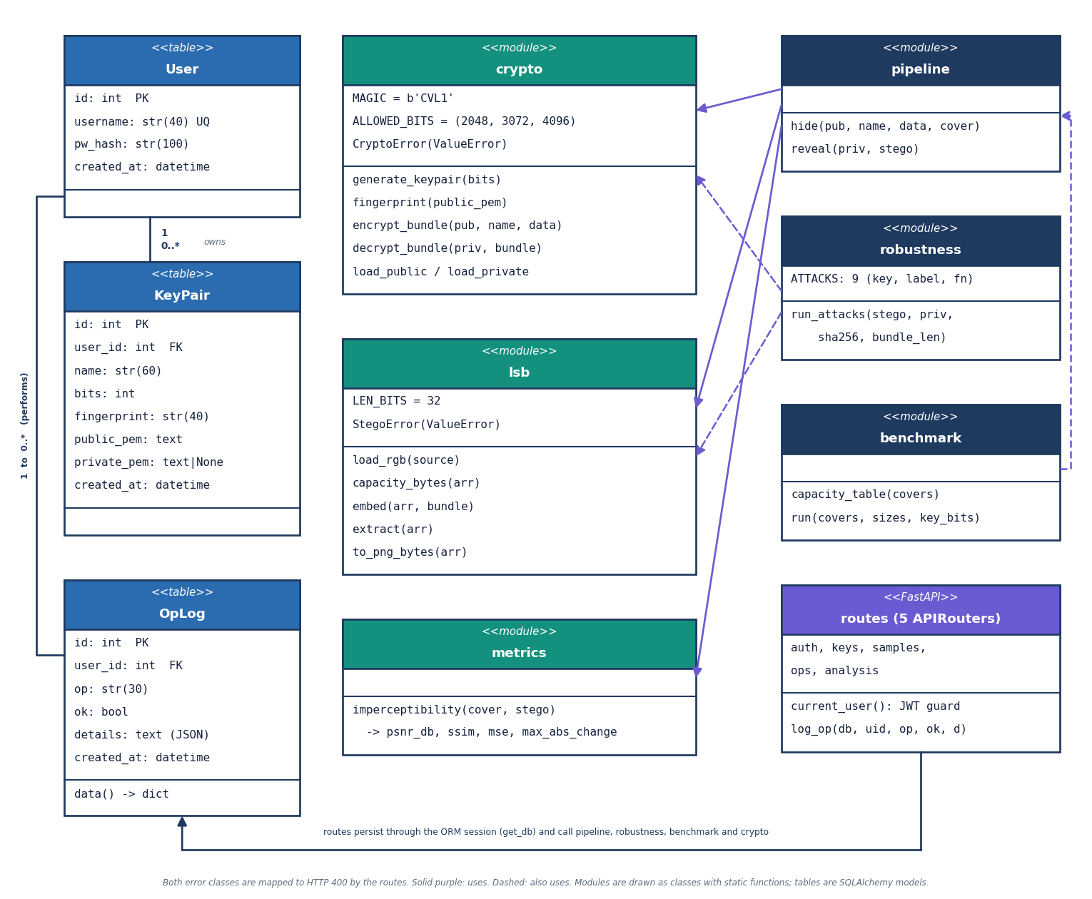
Figure 8: UML class diagram: the ORM classes, the service modules, the two error classes and the FastAPI routers.
Table 2: Principal classes and modules
Element | File | Role
User, KeyPair, OpLog | backend/app/db.py | The three database tables as SQLAlchemy classes
CryptoError | services/crypto.py | Raised for a bad key, wrong key, tag failure or foreign bundle
StegoError | services/lsb.py | Raised for an unreadable image, oversize payload or missing header
crypto | services/crypto.py | Key generation and loading, fingerprint, encrypt_bundle, decrypt_bundle
lsb | services/lsb.py | capacity_bytes, embed, extract, to_png_bytes, load_rgb
pipeline | services/pipeline.py | hide and reveal: the whole send and receive sequences with timings
robustness, benchmark, plots, metrics | services/ | Attacks and verdicts, capacity and speed tables, charts, PSNR and SSIM

The service layer is written as plain functions rather than a class hierarchy because the operations are pure transformations of bytes and arrays; only the database entities and the two error types are classes. This keeps the cryptography and the embedding free of web code and makes them directly testable.

1.4.2 Sequence diagram
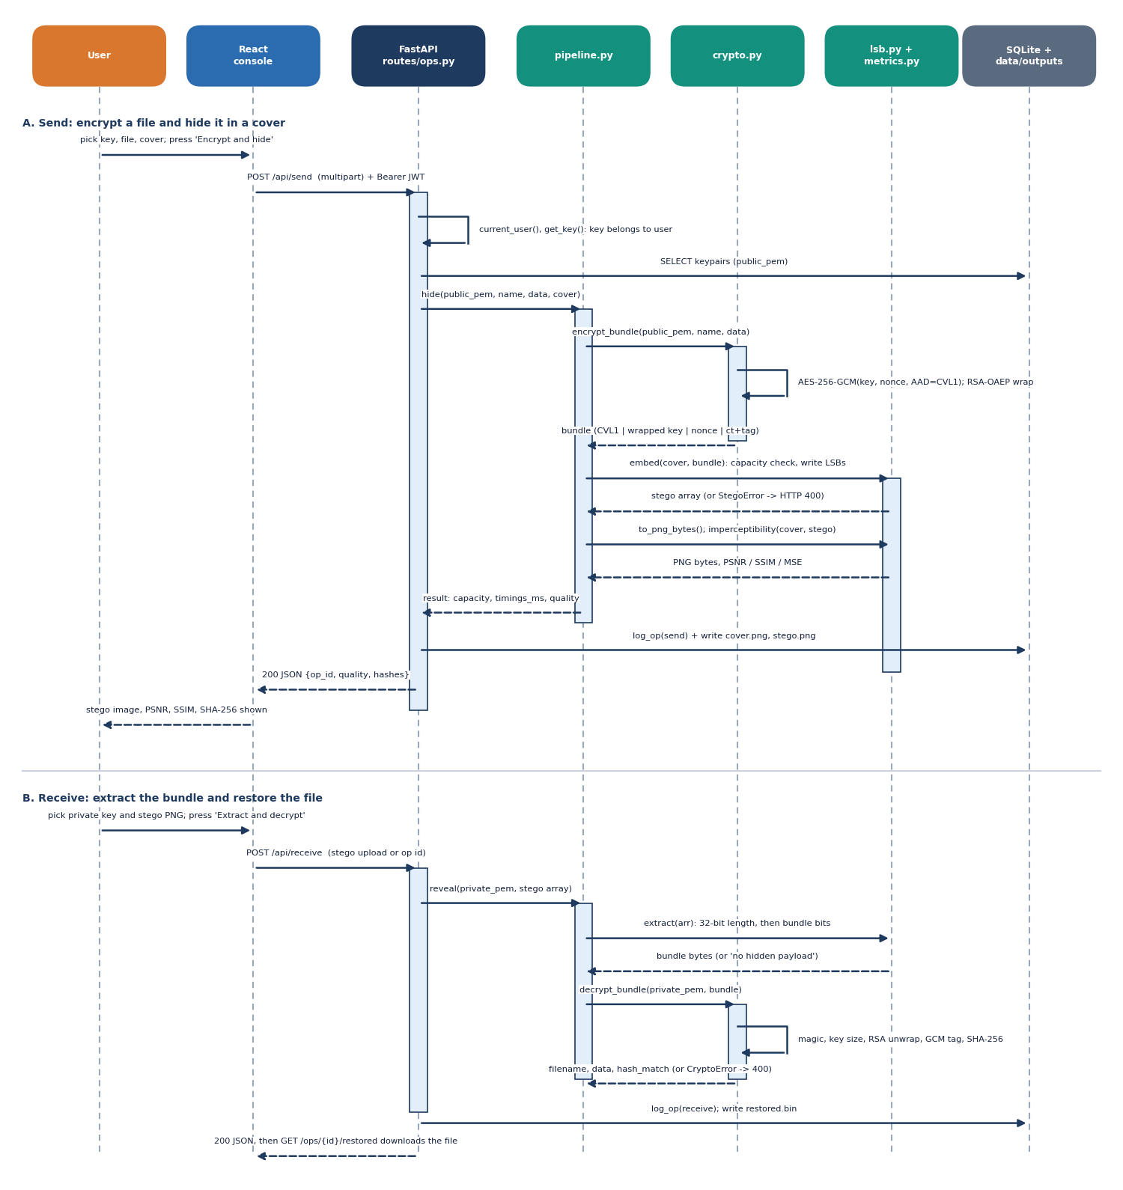
Figure 9: Sequence diagram of the main flow: the sender sends a file, the receiver extracts and decrypts it.
In the send scenario the console posts a multipart request to POST /api/send with the bearer token. current_user verifies the HS256 signature and expiry; the route loads the key (an ownership check), reads the payload and the cover, and calls pipeline.hide; on success it writes a row to oplog, stores the cover and the stego PNG under the operation number, and returns the metrics. In the receive scenario POST /api/receive loads the private key, calls pipeline.reveal, and returns the filename, the two hashes and gcm_verified; any CryptoError or StegoError becomes a 400 response with a message and a failed row in the log.

1.4.3 Use-case diagram
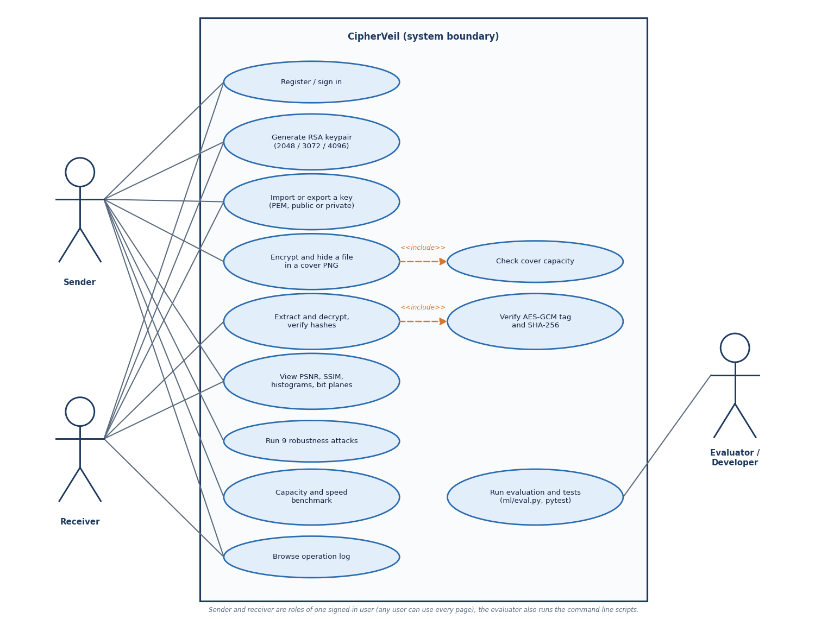
Figure 10: Use-case diagram with the sender, the receiver and the evaluator.
The sender imports or receives a public key, sends a file, reads the analysis and runs the robustness tests. The receiver generates a keypair, exports the public key, and extracts and decrypts. Both are the same application role (a signed-in user); the diagram separates them because they perform different use cases. The evaluator runs the benchmark and the scripts and reads the log.

1.5 Data Design
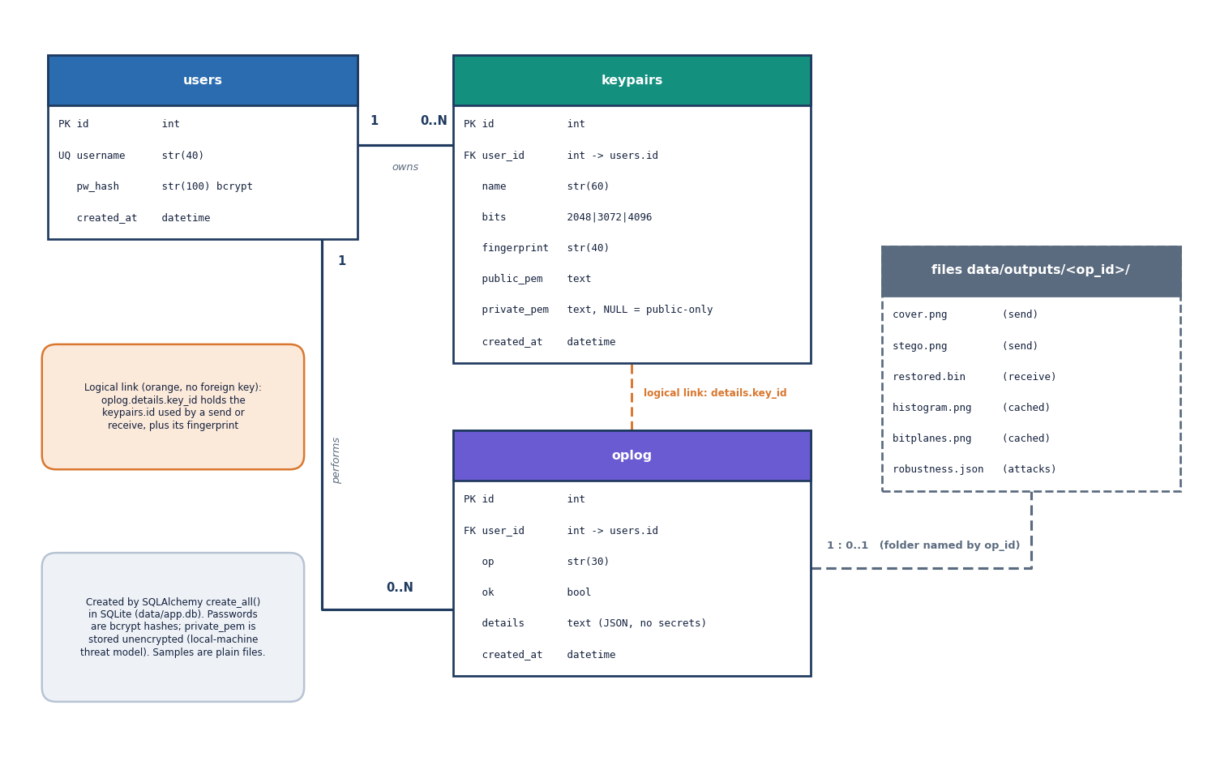
Figure 11: Entity-relationship diagram of the SQLite database: users, keypairs and the operation log.
The database has three tables. One user owns many keypairs and many log rows (1 : n each). A keypairs row stores the public PEM, a SHA-256 fingerprint of the public key (shown as twelve hex pairs) and, only for the owner's own keypairs, the private PEM; an imported recipient key has private_pem empty. The oplog row stores the operation, a success flag and a JSON text of sizes, timings and metrics.
Table 3: Database schema
Table | Columns | Notes
users | id, username (unique, 3-40 characters), pw_hash, created_at | Passwords stored as bcrypt hashes (72-byte limit)
keypairs | id, user_id (FK), name, bits, fingerprint, public_pem, private_pem (nullable), created_at | private_pem is stored unencrypted: a known gap
oplog | id, user_id (FK), op, ok, details (JSON text), created_at | No keys, passwords or file contents are ever passed to the logger

Files are kept beside the database: data/covers/ and data/payloads/ hold the six sample covers and four sample payloads; data/outputs/<operation id>/ holds cover.png, stego.png, the cached histogram and bit-plane images, restored.bin and robustness.json. The database and the outputs are not committed to the repository.

1.6 Module Design
Table 4: Backend modules
Module | Lines | Responsibility
services/crypto.py | 128 | RSA keypairs (2048, 3072, 4096), PEM loading with a 2048-bit floor, fingerprint, bundle encrypt and decrypt
services/lsb.py | 59 | Capacity, embedding and extraction with a 32-bit length prefix, PNG encoding
services/metrics.py | 21 | PSNR, SSIM, MSE, largest change, share of values changed
services/pipeline.py | 55 | hide and reveal with per-stage timings
services/robustness.py | 106 | Nine attacks, bit-error rate, a real decrypt attempt and a verdict per attack
services/benchmark.py, plots.py | 51 + 50 | Capacity and speed tables; histograms and bit-plane charts
routes/ (auth, keys, ops, analysis, samples) | 399 | 24 endpoints with validation, ownership checks and error mapping
auth.py, db.py, config.py, main.py | 171 | bcrypt and JWT, tables, settings from .env, application start-up and the demo account

The frontend has eight pages: Landing, Login, Keys, Send, Receive, Analysis, Robustness and Log, built from a small component set (controls, cards, tables, charts, feedback). A single Axios client adds the token, logs method, path and status to an in-browser activity log, and sends a signed-out user back to the login page on a 401.

1.7 API Design
Table 5: The 24 endpoints (all under /api; JWT required except health and auth)
Group | Endpoints
Health and auth (4) | GET /health; POST /auth/register, /auth/login; GET /auth/me
Keys (5) | GET /keys; POST /keys/generate, /keys/import; GET /keys/{id}/export?part=public|private; DELETE /keys/{id}
Samples (4) | GET /samples/covers, /samples/payloads, /samples/covers/{name}, /samples/payloads/{name}
Operations (3) | POST /send; POST /receive; GET /ops/{id}/cover|stego|restored
Analysis (8) | GET /analysis/{op}, /analysis/{op}/histogram.png, /analysis/{op}/bitplanes.png; POST and GET /robustness/{op}; GET /benchmark/capacity; POST /benchmark/run; GET /log

Errors follow one pattern: a 400 with a plain-language detail for a user mistake (oversize file, wrong key, unreadable image), 401 for a missing or expired token, 404 for something that does not exist or belongs to another user, 409 for a taken username, 413 for an upload above 25 MB and 422 for failed validation.

1.8 Security Design
• Confidentiality. A fresh AES-256 key and 96-bit nonce per message; the key is wrapped under RSA-OAEP with SHA-256 and MGF1-SHA-256; keys below 2048 bits are rejected.
• Integrity. The GCM tag covers the ciphertext and the magic as additional data; the SHA-256 in the header is checked after decryption.
• Access control. HS256 JWT valid for 12 hours; each key and operation is looked up with its owner and answers 404 to anyone else; sample names are resolved from a directory listing and never joined to a path.
• Input limits. 25 MB per upload; username pattern and password length checks; bcrypt on the first 72 bytes.
• Logging. The log records fingerprints and sizes only; a test scans it for key material.
Three gaps are part of the design and are stated rather than hidden: private keys are stored unencrypted in the local SQLite file, so data/app.db must be treated as sensitive; the repository's .env carries a placeholder JWT secret that must be replaced before any real use; and there is no rate limit on login. In addition, embedding is sequential from the first pixel and does not depend on a key, which is why statistical steganalysis can detect medium and high fill [15], [18] (Chapter 8).

1.9 User Interface Design
The console uses a dark theme with a left navigation (Keys, Send, Receive, Analysis, Robustness, Operation log) and a status panel that names the suite (AES-256-GCM, RSA-OAEP, LSB in PNG). Each action page has the same shape: a form on the left with a step indicator (Key, File, Cover, Hide), and the result on the right with the numbers and the images that matter. Errors appear in a red panel that says what failed and what to try, and the Send page warns before the request if the estimated bundle exceeds the cover capacity.
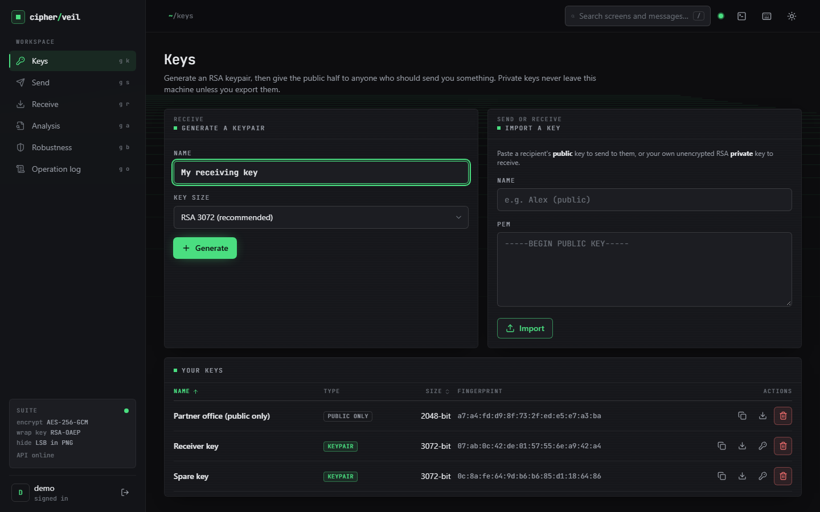  Figure 12: Keys page: two generated RSA-3072 keypairs and one imported public-only RSA-2048 key, with fingerprints. | 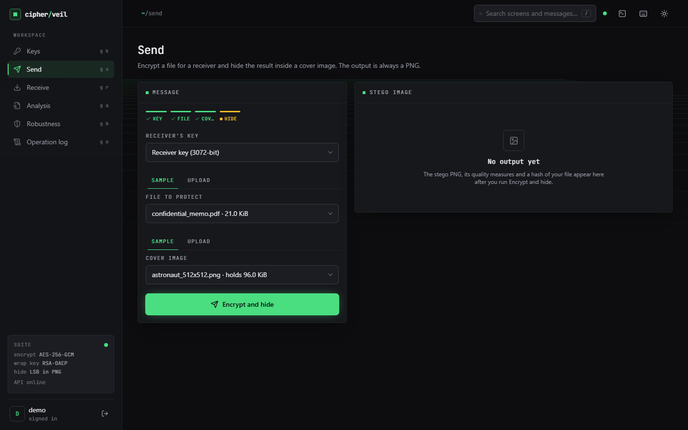  Figure 13: Send page: key, file and cover selected before the request.

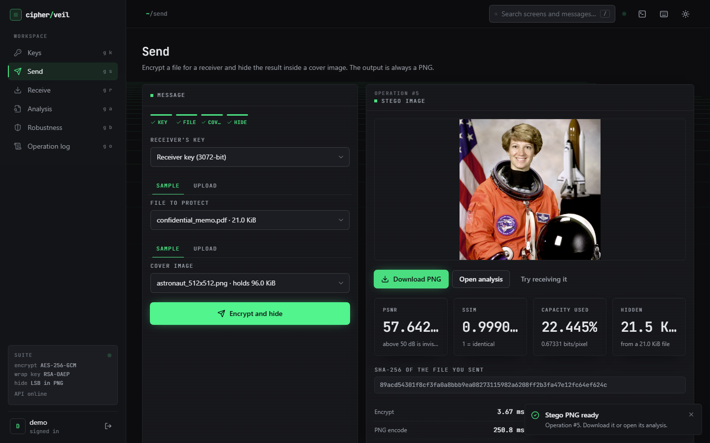  Figure 14: Send result: stego PNG, PSNR 57.642 dB, SSIM 0.9991, 22.445 % of capacity, hash of the sent file. | 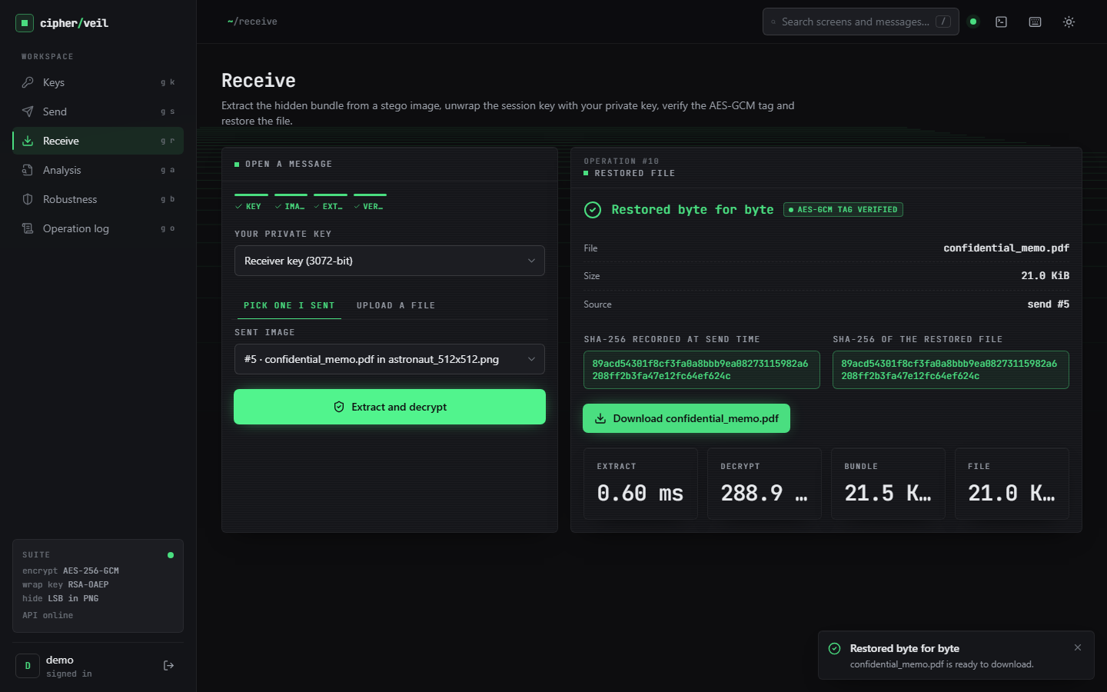  Figure 15: Receive result: tag verified, both SHA-256 values identical, file restored.

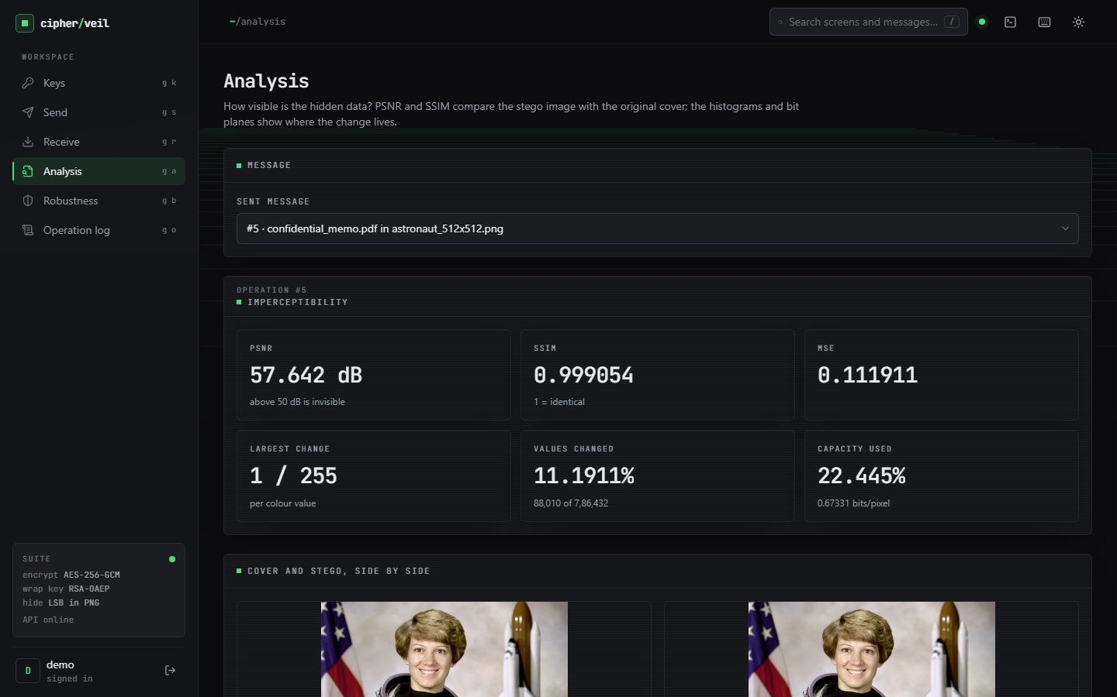
Figure 16: Analysis page: PSNR, SSIM, MSE, largest change, share of values changed and capacity used.
The remaining screens (histograms, bit planes, wrong-key failure, robustness, benchmark and log) are shown with their results in Chapter 8 and in Appendix C.

1.10 Design Decisions and Alternatives
Table 6: Main design decisions
Decision | Chosen | Alternative considered | Reason
Data cipher | AES-256-GCM | AES-CBC with a separate MAC | One authenticated primitive; a flipped bit is rejected before any output
Key transport | RSA-OAEP, SHA-256, 3072-bit default | Raw RSA, PKCS#1 v1.5, ECC | OAEP is the recommended RSA encryption padding [24], [23]; RSA keeps the key-pair story simple for a user
Session key | Fresh per message | One key per receiver | A compromised message key never exposes another message
Embedding | 1 bit per R, G, B value, sequential | Key-driven permutation, LSB matching, adaptive embedding | Simplest scheme with a closed-form PSNR and 3.0 bits per pixel; the stronger schemes [12], [13] are future work
Carrier format | PNG, RGB, alpha dropped | JPEG domain embedding | Lossless carrier keeps spatial LSBs exact; the price is that only lossless handling survives
Length header | 32 bits in the first LSBs | Terminator pattern | Capacity check and extraction need the length; a bad header is detected early
Persistence | SQLite via SQLAlchemy | Files only, or a server database | One file, no service to install; enough for a local tool
Service shape | Plain functions, shared pipeline | Class hierarchy per stage | The API, the benchmark and the evaluation run exactly the same code

Two of these choices carry the main trade-off of the project: a fixed, key-independent embedding order makes the arithmetic exact and the evaluation simple, but also makes the hiding detectable at medium and high fill; and the choice of a lossless carrier makes the extraction exact but limits the usable channels. Both are measured in Chapter 8.

1.11 Summary
The design keeps the cryptography and the embedding in small pure functions, shares one send and receive sequence between the API and the evaluation, scopes every key and operation to its owner, and records measurements instead of secrets. Chapter 6 gives the methodology and the implementation that realise it.

2. IMPLEMENTATION

2.1 Application architecture
The application has three tiers. The browser console is a React 18 single-page application built with Vite and styled with Tailwind CSS; it has eight screens (landing, login, keys, send, receive, analysis, robustness and benchmark, operation log) and talks to the backend only through an axios client that adds the bearer token. The backend is a FastAPI application on port 8315 with five routers (auth, keys, samples, operations and analysis), a thin layer of services, and SQLAlchemy models over SQLite. Files that are too large for a row (cover and stego PNGs, restored files, plots) are written to data/outputs/<operation id>/. The Vite development server on port 5315 proxies /api to the backend, so the browser sees one origin.
Table 7: Backend modules and their responsibilities.
Module | Lines | Responsibility
services/crypto.py | 128 | RSA key generation and checks, fingerprint, bundle encryption and decryption
services/lsb.py | 59 | Image loading, capacity, embed, extract, PNG encoding, LSB stream
services/metrics.py | 21 | PSNR, SSIM, MSE, largest change, values changed
services/pipeline.py | 55 | hide and reveal, with per-stage timings
services/plots.py | 50 | Histogram and bit-plane figures
services/robustness.py | 106 | Nine attacks, real decrypt attempt, error rate and explanation
services/benchmark.py | 51 | Capacity table and speed and quality benchmark
routes/ (5 files) | 399 | Request validation, ownership checks, logging, responses
auth.py, db.py, config.py, main.py | 171 | bcrypt and JWT, three tables, settings, application and demo user

The database has three tables. users holds the name and the bcrypt hash; keypairs holds the name, size, fingerprint, public PEM and, for a keypair the user owns, the private PEM (empty for an imported public key); oplog holds one row per operation with a JSON details field. Everything the log records is a size, a time, a metric, a file name or a key fingerprint; keys and file contents are never passed to it, and a test searches the log for key material.
Figure 17: System architecture of CipherVeil: browser console, FastAPI application, services and storage.

2.2 API design
All 24 routes sit under /api. Three are public (register, login and the health probe); the other 21 require a bearer token issued at login. Requests that carry files are multipart forms; the rest are JSON. Every failure returns a JSON body with a detail message that the console shows together with a hint.
Table 8: The 24 API routes.
Group | Method and path | Purpose
Auth | POST /api/auth/register, /login | Create an account or sign in; returns a 12-hour token
Auth | GET /api/auth/me | Current user
Keys | GET /api/keys | List the user's keys with fingerprints (no private PEM)
Keys | POST /api/keys/generate | Generate an RSA keypair of 2048, 3072 or 4096 bits
Keys | POST /api/keys/import | Import a public key (recipient) or an unencrypted private key (keypair)
Keys | GET /api/keys/{id}/export?part=public|private | Download a PEM; private export is logged
Keys | DELETE /api/keys/{id} | Delete a key
Samples | GET /api/samples/covers, /payloads | List sample covers (with capacity) and payloads
Samples | GET /api/samples/covers/{name}, /payloads/{name} | Download one sample
Operations | POST /api/send | Encrypt a file and hide it in a cover; returns metrics, capacity and timings
Operations | POST /api/receive | Extract, decrypt and verify; returns hashes and timings
Operations | GET /api/ops/{id}/cover, /stego, /restored | Download the files of an operation
Analysis | GET /api/analysis/{op} | Metrics of a send
Analysis | GET /api/analysis/{op}/histogram.png, /bitplanes.png | Plots, rendered once and cached
Analysis | POST /api/robustness/{op}; GET /api/robustness/{op} | Run the nine attacks; read the last report
Analysis | GET /api/benchmark/capacity; POST /api/benchmark/run | Capacity table; speed and quality benchmark
Analysis | GET /api/log | The user's operations, newest first, optional filter
System | GET /api/health | Liveness

Two design points are worth noting. First, send and receive return everything the screen needs in one response (metrics, capacity, timings, hashes), so each screen costs one round trip. Second, the sample routes resolve a name by listing the directory and comparing names, never by joining a user string to a path, which removes path traversal by construction.

2.3 Security and error handling
Security measures present in the code are the following. Passwords are stored as bcrypt hashes and limited to 72 bytes, the bcrypt maximum; tokens are HS256 JWTs that expire after 12 hours. Every key and every operation is fetched with a check that it belongs to the requesting user. RSA keys below 2048 bits are rejected on generation and on import. A bundle is rejected before any private-key operation if its magic is wrong or its wrapped-key length does not match the key, and the AES-GCM tag is verified before any plaintext is returned. Uploads are capped at 25 MB. CORS allows only the two local front-end origins.
The weaknesses are equally part of the design and are stated plainly. Private keys are stored unencrypted in the local SQLite file, so data/app.db is as sensitive as the keys. The shipped .env carries a placeholder JWT_SECRET that must be replaced for any shared use. There is no rate limit on login, the token is kept in the browser's local storage, and there is no sender authentication: anyone who holds the receiver's public key can send, and the receiver cannot tell who did.
Table 9: Errors the application detects and what the user sees.
Situation | Detected by | Response
Cover too small for the bundle | lsb.embed capacity check | 400: payload needs L bytes, cover holds only C bytes
Empty file, or file over 25 MB | send route | 400, or 413 "File is larger than 25 MB"
Upload is not an image | lsb.load_rgb | 400: could not read this file as an image
Image carries no payload | lsb.extract length check | 400: no hidden payload found
Bundle is not CipherVeil's | magic check | 400: no CipherVeil bundle found in this image
Wrong key size | wrapped-key length | 400: wrapped for a different key size
Wrong key, same size | RSA-OAEP decryption | 400: RSA unwrap failed - this is not the key the message was sent to
Image changed after sending | AES-GCM tag | 400: tag check failed - the data was modified
Public-only key used to receive | receive route | 400: no private key
Bad credentials, duplicate name, weak input | auth route and schema | 401, 409, 422
Missing or expired token | current_user | 401; the console returns to the login page
Unknown key, operation or sample | ownership and listing checks | 404

A send or receive that fails on a capacity, image or cryptographic error is also written to the log with its message, so the failure is visible afterwards without exposing any secret.

2.4 Installation and execution
CipherVeil runs offline on Windows with Python 3.11 or later and Node.js. It needs no API key, dataset or special hardware. The steps are:
1. Run setup.bat once. It creates the venv folder, installs the pinned Python packages (FastAPI 0.115.6, SQLAlchemy 2.0.36, cryptography 44.0.0, Pillow 11.0.0, NumPy 2.1.3, scikit-image 0.24.0, matplotlib 3.9.3, PyJWT, bcrypt), regenerates the sample covers if they are missing, and runs npm install in frontend.
2. Run run.bat. It opens the backend on port 8315 and the frontend on port 5315 in two windows and opens the browser. The ports are fixed in .env.
3. Sign in with the demo account demo / Demo@12345, which the backend creates at first start, or register a new account.
4. Follow the screens in order: Keys (generate a keypair), Send (choose key, file and cover; encrypt and hide; download the PNG), Analysis, Receive (choose the key and the stego image), Robustness and Log.
5. Check the installation with venv\Scripts\python -m pytest (39 tests), venv\Scripts\python scripts\smoke_test.py against the running backend (21 checks), venv\Scripts\python ml\eval.py (writes experiments/eval/metrics.json), and npm run build in frontend.
If the browser shows a blank page or a 502, the backend window did not start and its output explains why. If a port is busy, change it in .env. If the recipient cannot open an image, it was almost certainly re-encoded by a messaging application; send the PNG as a file or in an archive. Appendix B gives the complete user guide.

3. KEY CODE WALK-THROUGHS

3.1 Building the bundle (`crypto.encrypt_bundle`)
The function builds the header, encrypts header and file together with a fresh key and nonce, wraps the key and concatenates the fields. The header is encrypted too, so the file name and hash are not visible to anyone who finds the bundle.
def encrypt_bundle(public_pem: str, filename: str, data: bytes) -> tuple[bytes, dict]:
"""Return (bundle, info). A fresh AES session key and nonce are used for every call."""
pub = load_public(public_pem)
header = json.dumps({"name": os.path.basename(filename) or "payload.bin", "size": len(data),
"sha256": sha256_hex(data)}).encode()
plaintext = struct.pack(">H", len(header)) + header + data

session_key = AESGCM.generate_key(bit_length=256)
nonce = os.urandom(NONCE_LEN)
ciphertext = AESGCM(session_key).encrypt(nonce, plaintext, MAGIC)
wrapped = pub.encrypt(session_key, _OAEP)

bundle = MAGIC + struct.pack(">H", len(wrapped)) + wrapped + nonce + ciphertext
return bundle, {"input_sha256": sha256_hex(data), "wrapped_key_bytes": len(wrapped),
"bundle_bytes": len(bundle), "overhead_bytes": len(bundle) - len(data)}

AESGCM.generate_key(256) and os.urandom(12) are called for every message. The magic CVL1 is passed as associated data, so it is authenticated without being encrypted. _OAEP is OAEP with SHA-256 for both the hash and the mask function. The returned overhead_bytes is the difference between bundle and file size, shown on the Send screen.

3.2 Opening the bundle (`crypto.decrypt_bundle`)
def decrypt_bundle(private_pem: str, bundle: bytes) -> tuple[str, bytes, dict]:
"""Return (filename, data, info). Raises CryptoError when the key or the tag is wrong."""
if len(bundle) < 6 + NONCE_LEN + 16 or bundle[:4] != MAGIC:
raise CryptoError("No CipherVeil bundle found in this image")
priv = load_private(private_pem)
(wlen,) = struct.unpack(">H", bundle[4:6])
if wlen != priv.key_size // 8:
raise CryptoError("This bundle was wrapped for a different key size - wrong private key")
wrapped = bundle[6:6 + wlen]
nonce = bundle[6 + wlen:6 + wlen + NONCE_LEN]
ciphertext = bundle[6 + wlen + NONCE_LEN:]
try:
session_key = priv.decrypt(wrapped, _OAEP)
except Exception as exc:
raise CryptoError("RSA unwrap failed - this is not the key the message was sent to") from exc
try:
plaintext = AESGCM(session_key).decrypt(nonce, ciphertext, MAGIC)
except InvalidTag as exc:
raise CryptoError("AES-GCM tag check failed - the data was modified") from exc

(hlen,) = struct.unpack(">H", plaintext[:2])
header = json.loads(plaintext[2:2 + hlen])
data = plaintext[2 + hlen:]
return header["name"], data, {"embedded_sha256": header["sha256"], "output_sha256": sha256_hex(data),
"match": header["sha256"] == sha256_hex(data), "size": len(data)}

Every failure maps to a specific CryptoError: no magic, wrong key size, failed RSA unwrap, failed tag. Nothing is returned until the GCM tag has verified, and the final dictionary reports whether the recorded hash equals the hash of the restored bytes.

3.3 Embedding and extracting (`lsb.py`)
def embed(arr: np.ndarray, bundle: bytes) -> np.ndarray:
cap = capacity_bytes(arr)
if len(bundle) > cap:
raise StegoError(f"Payload needs {len(bundle)} bytes but this cover holds only {cap} bytes. "
"Choose a larger cover or a smaller file.")
framed = len(bundle).to_bytes(4, "big") + bundle
bits = np.unpackbits(np.frombuffer(framed, dtype=np.uint8))
flat = arr.reshape(-1).copy()
flat[:bits.size] = (flat[:bits.size] & 0xFE) | bits
return flat.reshape(arr.shape)

def extract(arr: np.ndarray) -> bytes:
flat = arr.reshape(-1)
if flat.size < LEN_BITS:
raise StegoError("Image is too small to contain a payload")
length = int.from_bytes(np.packbits(flat[:LEN_BITS] & 1).tobytes(), "big")
if length == 0 or length > capacity_bytes(arr):
raise StegoError("No hidden payload found (length header is invalid)")
bits = flat[LEN_BITS:LEN_BITS + length * 8] & 1
return np.packbits(bits).tobytes()

The bundle is prefixed with its 32-bit length, unpacked into bits and written into the lowest bit of the first n colour values with one vectorised mask (& 0xFE) and an OR. The capacity check comes first and produces the message shown on the Send screen. extract reads the length, rejects a zero or impossible length, and packs the following bits back into bytes.

3.4 The pipeline (`pipeline.py`)
def hide(public_pem: str, filename: str, data: bytes, cover: np.ndarray) -> dict:
t = time.perf_counter()
bundle, enc_info = crypto.encrypt_bundle(public_pem, filename, data)
encrypt_ms = _ms(t)

cap = lsb.capacity_bytes(cover)
t = time.perf_counter()
stego = lsb.embed(cover, bundle) # raises StegoError when it does not fit
embed_ms = _ms(t)

t = time.perf_counter()
png = lsb.to_png_bytes(stego)
encode_ms = _ms(t)

t = time.perf_counter()
quality = metrics.imperceptibility(cover, stego)
metrics_ms = _ms(t)

...
def reveal(private_pem: str, stego: np.ndarray) -> dict:
t = time.perf_counter()
bundle = lsb.extract(stego)
extract_ms = _ms(t)
t = time.perf_counter()
name, data, info = crypto.decrypt_bundle(private_pem, bundle)
decrypt_ms = _ms(t)
return {"filename": name, "data": data, "info": info, "bundle_len": len(bundle),
"timings_ms": {"extract": extract_ms, "decrypt": decrypt_ms}}

hide times encryption, embedding, PNG encoding and the quality measures separately, which is why the log can show that PNG encoding and SSIM, not the cryptography, take most of a send. reveal returns the extraction and decryption times separately for the same reason. The API, the benchmark and ml/eval.py all call these two functions, so the same code produces the screens and the numbers.

3.5 Attacking the image (`robustness.run_attacks`)
def run_attacks(stego: np.ndarray, private_pem: str, original_sha256: str, bundle_len: int) -> list[dict]:
n_bits = (bundle_len + 4) * 8
ref_bits = lsb.lsb_stream(stego, n_bits)
results = []
for key, label, fn in ATTACKS:
attacked = fn(stego)
t = time.perf_counter()
ber = None
flat_bits = lsb.lsb_stream(attacked, n_bits)
m = min(flat_bits.size, ref_bits.size)
if m:
ber = round(float(np.mean(flat_bits[:m] != ref_bits[:m])), 4)
status, detail = "lost", ""
try:
bundle = lsb.extract(attacked)
name, data, info = crypto.decrypt_bundle(private_pem, bundle)
if info["output_sha256"] == original_sha256:
status, detail = "recovered", "Byte-for-byte identical to the original file."
else:
detail = "Decrypted but hash differs."
except (lsb.StegoError, crypto.CryptoError) as exc:
detail = str(exc)
except Exception as exc: # corrupted header can raise anything while parsing
detail = f"Payload could not be parsed ({type(exc).__name__})"
results.append({
"attack": key, "label": label, "status": status, "detail": detail,
"bit_error_rate": ber, "why": EXPLAIN[key],
"elapsed_ms": round((time.perf_counter() - t) * 1000, 2),
"size": f"{attacked.shape[1]}x{attacked.shape[0]}",
})
return results

Each attack is a function from image to image; the result is decided by a real extraction, a real decryption and a hash comparison, not by a bit-error threshold. The bit error rate is computed against the unattacked LSB stream only for the report. Any exception while parsing a corrupted header is caught and reported as 'lost'.

3.6 Serving a send request (`routes/ops.py`)
@router.post("/send")
async def send(key_id: int = Form(...),
payload: UploadFile | None = File(None), payload_sample: str | None = Form(None),
cover: UploadFile | None = File(None), cover_sample: str | None = Form(None),
user: User = Depends(current_user), db: Session = Depends(get_db)):
key = get_key(db, user, key_id)

if payload is not None and payload.filename:
filename, data = payload.filename, await read_upload(payload)
elif payload_sample:
p = sample_path(PAYLOADS_DIR, payload_sample)
filename, data = p.name, p.read_bytes()
else:
raise HTTPException(400, "Choose a file to protect")
if not data:
raise HTTPException(400, "The file is empty")

try:
if cover is not None and cover.filename:
cover_name, cover_arr = cover.filename, lsb.load_rgb(await read_upload(cover))
elif cover_sample:
p = sample_path(COVERS_DIR, cover_sample)
cover_name, cover_arr = p.name, lsb.load_rgb(str(p))
else:
raise HTTPException(400, "Choose a cover image")
result = pipeline.hide(key.public_pem, filename, data, cover_arr)
except (lsb.StegoError, crypto.CryptoError) as exc:
log_op(db, user.id, "send", False, {"error": str(exc), "payload_bytes": len(data)})
raise HTTPException(400, str(exc))

details = {
"key_id": key.id, "key_name": key.name, "fingerprint": key.fingerprint, "key_bits": key.bits,
"filename": filename, "payload_bytes": len(data), "cover": cover_name,
"input_sha256": result["info"]["input_sha256"], "bundle_bytes": result["bundle_len"],
"capacity": result["capacity"], "timings_ms": result["timings_ms"], "quality": result["quality"],
}
row = log_op(db, user.id, "send", True, details)
d = op_dir(row.id)
(d / "cover.png").write_bytes(lsb.to_png_bytes(cover_arr))
(d / "stego.png").write_bytes(result["stego_png"])
return {"op_id": row.id, **details}

The route accepts an uploaded file or the name of a committed sample (resolved by directory listing, never by joining the name to a path), calls pipeline.hide, logs success or failure, and stores the cover and stego PNGs under the operation id. Errors from the library become HTTP 400 with the library's own message, and the same message is written to the log, which is what the Send and Log screens display.

4. IMPLEMENTATION DECISIONS AND THEIR REASONS
The table lists the main implementation decisions with the reason for each and the consequence that was observed.
Table 10: Implementation decisions and their reasons
Decision | Reason | Consequence observed
AES-256-GCM instead of AES-CBC or CTR | Authenticated encryption detects tampering without a separate MAC | All 240 bit flips rejected; one primitive provides secrecy and integrity
A new session key and nonce for every message | Removes nonce reuse, the main way GCM fails, and limits the damage of a leaked key to one message | 50 encryptions of one file gave 50 distinct nonces and wrapped keys
RSA-OAEP with SHA-256 for the key, default 3072 bits | OAEP is the recommended padding; 3072 bits balances security and speed | Unwrap takes 94 ms (3072) against 31 ms (2048) and 221 ms (4096); overhead 529 B
Magic as GCM associated data and header inside the encrypted part | Authenticates the format and hides file name and hash | Bundles are not confusable; the receiver can verify the file hash
1 LSB per R, G and B value, sequential | Simple, fast and predictable capacity (3.0 bits per pixel); PSNR can be computed in advance | PSNR within 0.053 dB of the model; detectable by chi-square
32-bit length header before the bundle | Lets the receiver know how many bits to read without scanning | A clean image is rejected (a random 32-bit value almost always exceeds the capacity); a wrong but plausible length is caught by the magic check
PNG output only | Lossless compression keeps every pixel value | Payload survives re-save and WebP lossless, not JPEG
Capacity check before embedding | Fail early with exact numbers instead of truncating | Eight of 30 evaluation combinations were refused with a clear message
Measure PSNR, SSIM and MSE in the send path | The user should see the cost of every message | About 300 ms of each send is spent on the measures, more than all cryptography
Resolve sample names by directory listing | Blocks path traversal without a deny-list | Traversal requests return 404 in the tests
bcrypt for passwords and HS256 JWT for sessions | Standard, slow hashing; stateless sessions | Login takes 287 ms; the JWT is stored in the browser, which is acceptable for a local tool
Store private keys in the database | Keeps the demo to one component and lets the Receive screen work after a restart | Convenient but unsafe at rest; listed as a limitation and as future work
Run the evaluation on the same services as the API | One code path for numbers and screens | ml/eval.py, the benchmark page and the tests agree

